**Activity 1**

Find the attached sheet with triangles at the bottom of this document. Print it out in colour or black and white. If in school, photocopy this for the class. If the children are at home, print it out for use at home.

Cut out the triangles from this sheet of paper.

Turn them over and reassemble to make a square.

When you have completed a square flip them over again and repeat the process. You can continue to do this as many times as you would like. Perhaps colour in one side orange or blue for example or time yourself to see if you can complete the square faster each time.

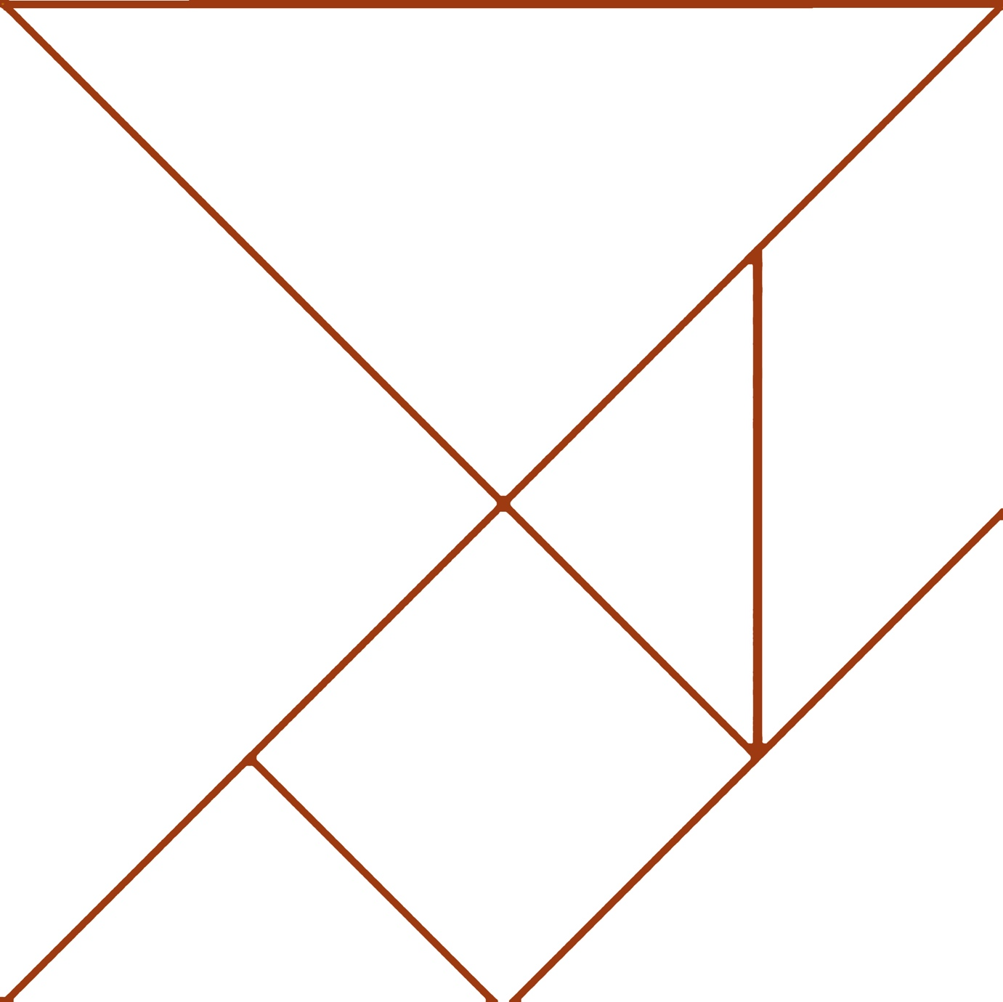

**Activity 2**

Have a look at the image below. Is there something different or unusual about what you see?

Trees come in all shapes and sizes but incredibly what you see above the ground is the same as what is below the ground. A tree’s root system grows in a similar way to the branches. They grow long and deep and spread out to find water and food, keeping the tree alive but also keeping it steady so it doesn’t fall over in the wind.

Get a sheet of paper (A4 or A3 size) and using a pencil, or pen or crayon, draw a tree that you can see. You might find a tree outside your classroom window or go for a walk in your school yard or at home.

Think about the branches of the tree, think about the roots that you cannot see. You can decide to include the roots of the tree in your drawing or just focus on the branches.

When you are finished the drawing, fold your page in half and cut along this line with scissors.

You should now have two pieces of paper with your drawing on it. Swap one of these pieces of paper with someone else in your class. If you are at home, consider doing a second drawing and mix them up. Once you have two different drawings on two different pieces of paper, turn them over and use sticky tape to stick them together.

You can now turn over the page and you should have one drawing made from two different trees or drawn by different people. Stick them on your wall and compare with the other people in your class.

You can repeat this as many times as you want.

**Activity 3**

Using a computer or tablet please visit the website below

[www.shiftingpatternsoflight.com](http://www.shiftingpatternsoflight.com)

What can you see on the screen?

Using your mouse or finger (if using a tablet), click anywhere on the screen.

Can you notice what is happening?

When you click the mouse button a new node is created. A node is one of the dots that make up the triangular type shapes. When a new node is created it will then draw a line to the nearest dot, becoming part of this new geometric shape. As the nodes move around the screen, they will make new connections depending on where it is at that time and where the next closest node is.

Have some fun clicking on the screen and watch what happens to your new nodes and shapes.

See if you can follow one particular node around the screen for 30 seconds. Watch where it goes and count how many times it can make a new connection.

There is no limit to the number of nodes you create, however, if you have lots and lots of new nodes it might slow down, and you can refresh the webpage to start again.